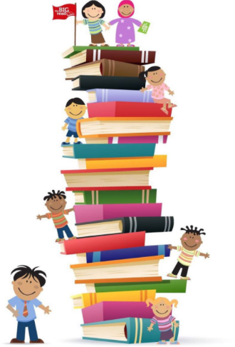

Ten-At-A-Time Book Club
2018-19
Log 2
Fill in each box with the title and author of the book read. See the back of the log for the description of each genre/category. Books must be on the student’s reading level, and must be new to the student and read/listened to from September 1, 2018- April 5, 2019. When this log is complete, bring it to the library for your prizes and recognition and to get Log #3.

Historical Fiction  Title:  Author: | Fantasy Fiction  Title:  Author:
Science Fiction  Title:  Author: | Realistic Fiction  Title:  Author:
Mystery Fiction  Title:  Author: | Award Winner  Title:  Author:
A How-To Book  Title:  Author: | Biography/Autobiography  Title:  Author:
An Informational Book  Title:  Author: | Free Choice  Title:  Author:

Name___________________________________________

Teacher_________________________________________

Parent Signature_________________________________

Do you want the next Log? YES NO

